Email to CS Dept Professors
mihirkavishwar96@gmail.comMay 24, 2023

List of professors
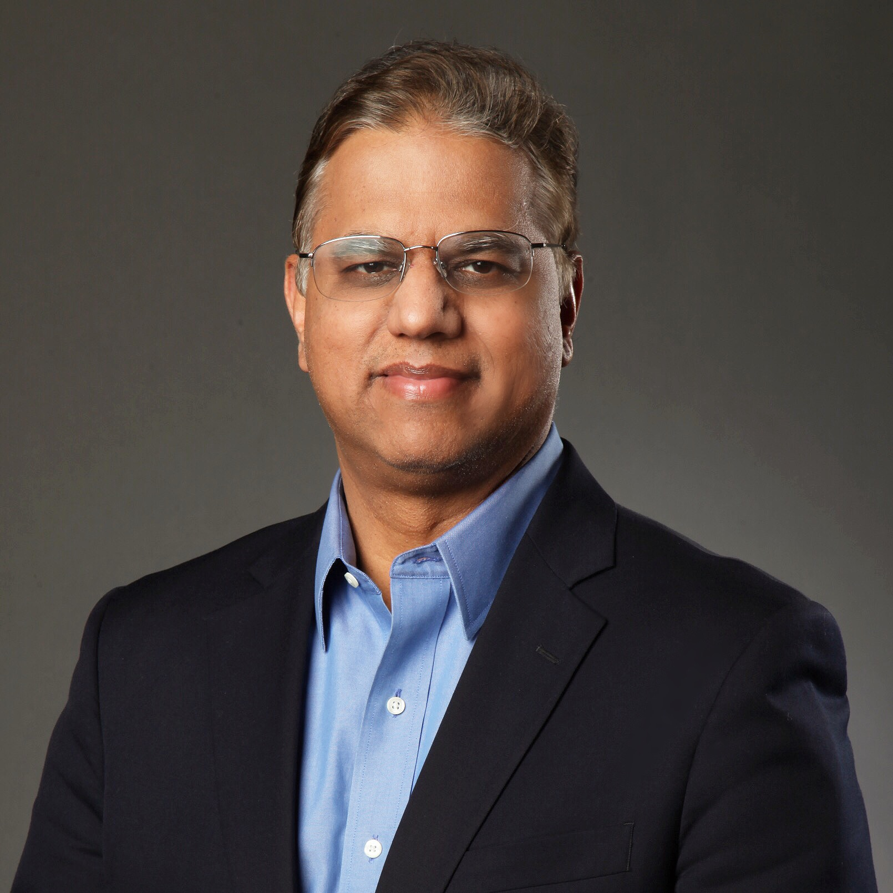

Satyandra K. Gupta
Smith International Professorship in Mechanical Engineering and Professor of Aerospace and Mechanical Engineering and Computer Science
guptask@usc.edu

Faculty Directory - USC Viterbi | Thomas Lord Department of Computer Science

Email Draft

To
Cc | dardalan@usc.edu mkavishw@usc.edu devin.g.ardalan@gmail.com mihirkavishwar96@gmail.com
Bcc
Subject | Invitation to Participate in Coding Competition for CS Students - Dandelion Startup
Hello professor __,

I am Mihir Kavishwar, currently enrolled as a master's student in USC Viterbi Engineering Management program. I am reaching out to you along with my project partner, Devin Ardalan, who is pursuing a master's degree in Entrepreneurship and Innovation. Together, we have embarked on a startup venture named Dandelion, which aims to assist young entrepreneurs in creating prototypes through coding competitions. We are reaching out because we wanted to ask if you could pass along our invitation to your class or previous CS students that may be interested for our very first competition.

Our team has been approached by a client who wishes to develop a web application for her company. In order to accomplish this, we would like to organize a competition exclusively for CS students. We kindly request your assistance in spreading the word to your students.

For easy access, we have provided a competition signup link: https://forms.gle/aHpK54HU9HTbzmaV9

Additionally, we have attached comprehensive details about the competition.

Please let us know if you have any questions or suggestions. Thank you for your time and support.

Best regards,
Mihir Kavishwar
USC Viterbi Engineering Management Master's Student

